

**Your Invitation to**

**‘A Wildlife Vision for Milford’s**

**Coast & Farmland’**

**Presented by Keith Metcalf**

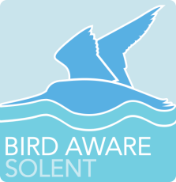

**Plus the work of Bird Aware Solent by Ranger ~ Julie Sims**

**Milford-on-Sea Community Centre**

**Friday 28th October at 3pm**

**Reserve your seat by emailing:**

[**keithmetcalf2022@btinternet.com**](mailto:keithmetcalf2022@btinternet.com)

**Suggested ticket donation of £5.00 towards costs and ‘WINGS WILDLIFE VISION PROJECTS’**