**Brief Information about MCV members standing for election at MCV’s AGM on 11 April 2023**

Chris Barrass

Hello, I am seeking re-election to the MCV committee. Originally from the Northeast, we moved down to Milford in 1964. I have always been interested in wildlife photography and spend a lot of time in the forest. I have also done some volunteering work in South Africa (Phinda private game reserve) and Botswana (Okavango delta). I am retired and now spend a lot of time recording the birds at the Observatory in Keyhaven

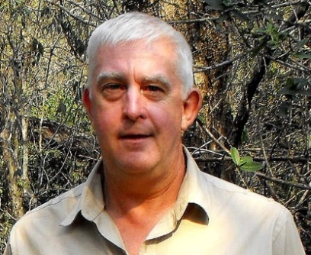

David Cobbett

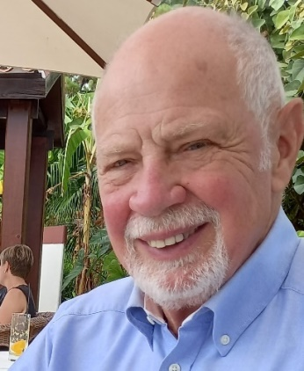

I moved into Milford on Sea from Ripley in Surrey in 2015 and joined MCV in 2016.

I became Treasurer and Membership Secretary in 2017. I have held these posts ever since and am now standing for re-election for both of them. I am also a keen member of MCV’s Logging team. My other interests are gardening, reading and travelling. I am seeking re-election to the posts of Treasurer and Membership Secretary.

Penny Gladman

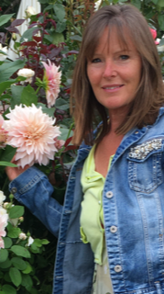

Hi everyone, I’m a newcomer to MCV, having moved to Keyhaven last October with my husband. My background is in agricultural property law and, being a nature lover, I would like to join the committee this year to help conserve the beautiful environment we live in.  I’m a new member of the MCV tasking team and, like Chris, am interested in wildlife photography and have also volunteered as a photographer in Africa (Antelope Park private game reserve, Zimbabwe). In my spare time I enjoy outdoor activities on and off the water and am looking forward to learning more about our wetlands and diverse birdlife.

Julie Hallows

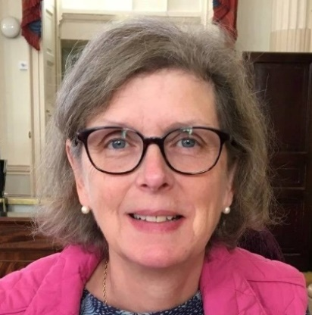

My husband and I moved to Milford on sea 6 years ago, having visited my parents-in-law here over many years while our children were younger. My interest in conservation is based on a life long, but non-expert, interest in birds. With a background in IT project management, I would be willing to look after the MCV website and help in other matters as a general committee member.

David Horne

I am still enjoying a life-long passion with wetlands and birds.  After gaining a degree in Aquatic Ecology I had a career spanning some 30 years with the Environment Agency, involved mainly with pollution prevention work in the New Forest catchment area.  Now that I have retired I am trying to broaden my knowledge of plants and insects. I have lived in Hordle for 21 years.  After taking part in some of its task sessions I joined MCV in about 2017 and became its chairman in 2020, the role for which I am standing for re-election.

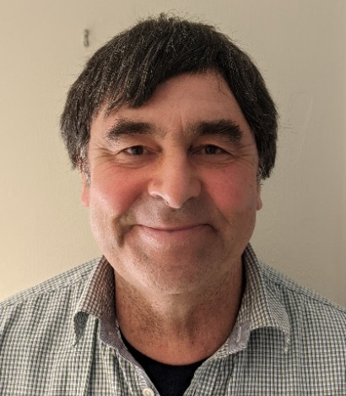

Lorraine Mabbett

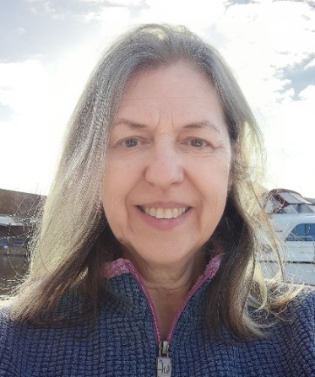

My husband Steve and I moved to Milford on Sea in 2015, having both taken early retirement.  I had enjoyed some 30 years of public service, my last post being Deputy Chief Constable of Gwent Police.  After retiring I knew that I wanted to continue to develop my keen interest in conservation and wildlife and to keep myself and my mind active so we joined MCV as soon as we arrived.  I have been an active member of MCV since then and now I work alongside Steve organising the logging sessions and I organise MCV's tasking sessions, working closely with our Parish Council.

Adrian Palmer

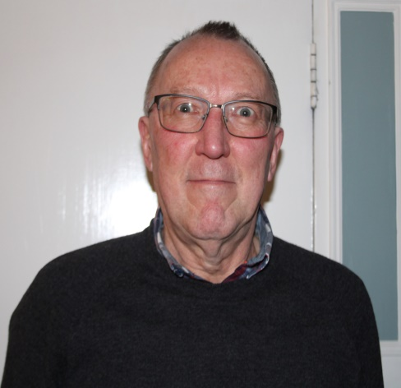

I originally moved to Lymington from Windsor with my parents in 1970. I enjoyed the freedom of exploring the New Forest and the coast on my bike, spotting birds and wildlife I had not seen before and spending some of my school summer holidays on Milford beach with my friends. College, career, and marriage pulled me away to other areas of the UK and overseas, but in 1997 returned to Lymington with my family although my travels for my work in engineering consultancy continued until Covid-19 arrived. I retired in March 2022 and joined MCV to contribute to conservation efforts in the area that I feel privileged to live and hopefully to enhance my bird spotting skills.

Penny Ramus

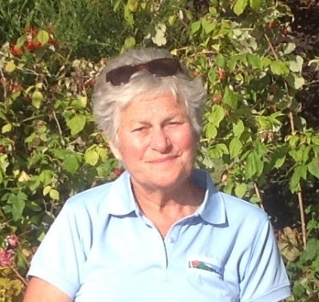

We have lived in Milford on Sea for almost 14 years. We were soon amazed to find what a wonderful village we had moved to. In order to get to know people we joined MCV and have enjoyed working with the volunteers ever since. In time the physical tasks became difficult for me to fit in with my other interests. I therefore volunteered to join the Management Committee and have now been taking the minutes for almost four years during which time MCV has grown in stature and is taking on more and more interesting and vital projects making the work for the Committee challenging but very rewarding.